SWAG LABS  
website Link: <https://www.saucedemo.com/>

**Introduction:**

This document outlines the testing strategy for the SauceDemo Ecommerce website. The objective is to thoroughly test the application before release to ensure it functions as intended and delivers a smooth user experience.

**Scope of Testing:**

***In Scope:***

Login Page

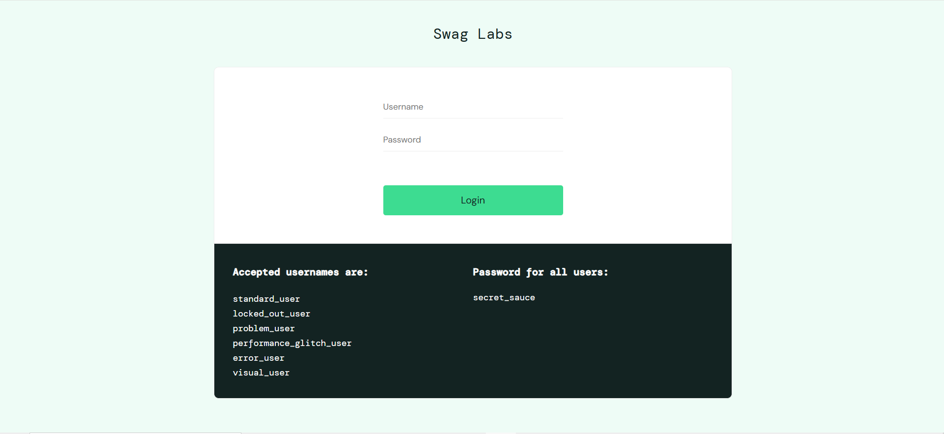

Products / Inventory Page

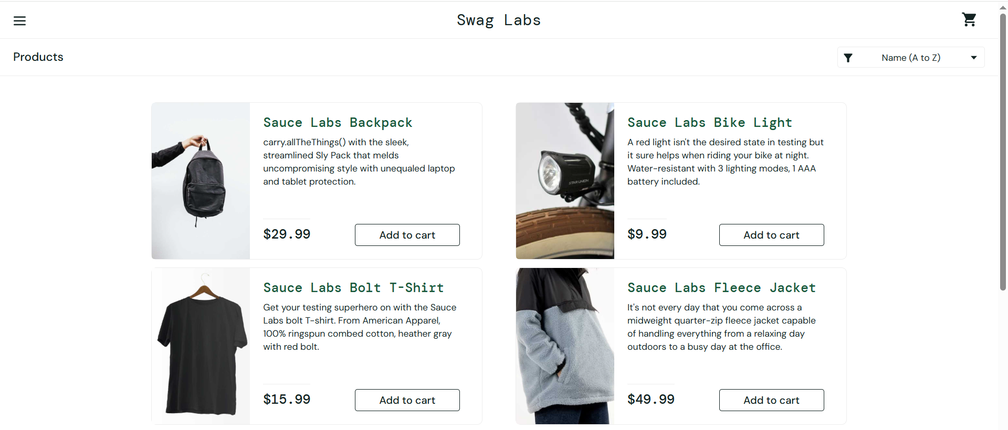

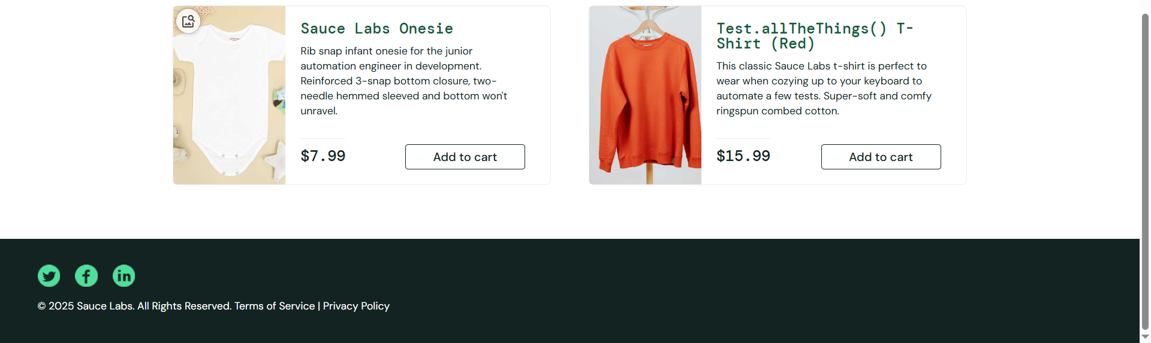 Cart Page  
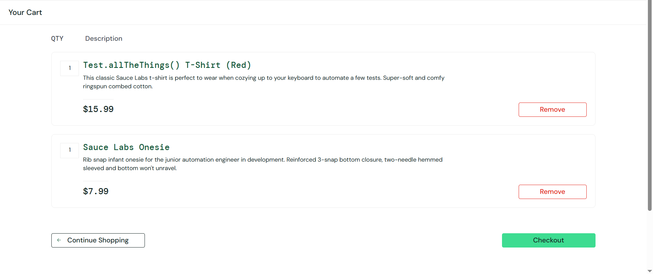

Checkout Step One  
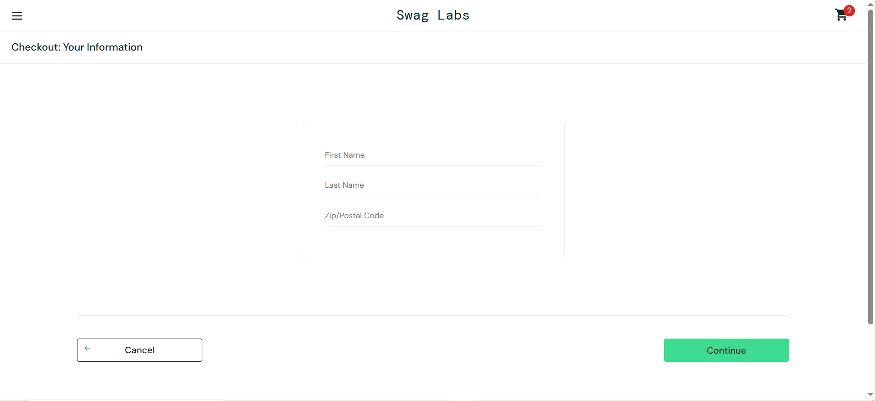

Checkout Step Two  
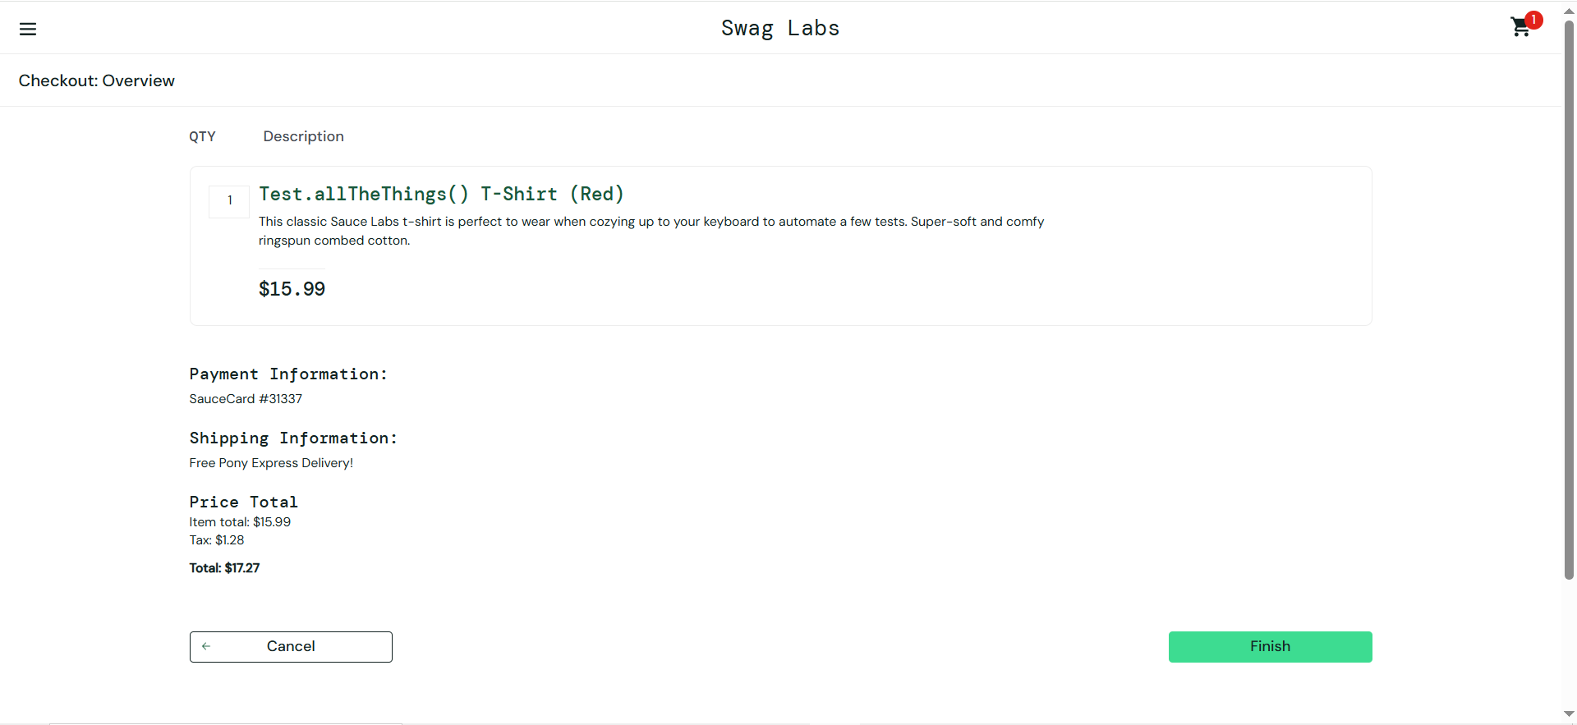

Checkout complete  
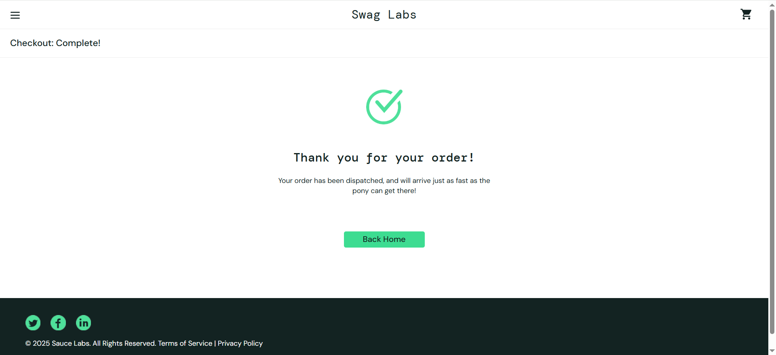

***Out Scope:***

Registration Page , Payment Gateway, Your Order History

**Test Objectives:**

* Validate login authentication functionality.
* Ensure the product page displays products with accurate details, prices, and a functional "Add to Cart" button.
* Verify the "Sort By" functionality for correct product sorting.
* Confirm the "Add to Cart" button and cart icon work correctly for a smooth user experience.
* Verify that the cart page displays selected products correctly and the remove button works as expected.
* Test the functionality of the "Continue Shipping" and "Checkout" buttons.
* Ensure the checkout process works seamlessly from cart to order confirmation.
* Verify that all order details (product, quantity, price, shipping) are correctly shown on the checkout overview page for final review.
* Confirm that after clicking the "Finish" button, an order confirmation message is displayed along with a working "Back to Home" button.

**Testing Approach:**

* ***Methodologies*:** Manual Testing
* ***Types of Testing*:** Functional Testing, Ui Testing, smoke testing
* ***Tools:*** Browser, Excel

**Test Schedule:**

|  |  |  |
| --- | --- | --- |
| **Phase** | **Start Date** | **End Date** |
| Test Planning | 03-May-2025 |  |
| Test Case Design | **05-July-2025** | **7-July-2025** |
| Test Execution | **7-July-2025** | **7-July-2025** |
| Test Completion |  |  |

**Test Environment:**

* **Hardware/Software:** Chrome on Windows 10
* **Staging URL or App Version:** <https://www.saucedemo.com/>
* **Test Data Sources:** data provided by site & dummy data

**Resources & Responsibilities:**

|  |  |  |
| --- | --- | --- |
| **Role** | **Name** | **Responsibilities** |
| **QA Engineer** | Abdul Rafay Sabir | Test Plan Creation,  Writing & Executing Test Cases,  Bug Reporting,  Manual Testing Execution |

**Risks & Mitigation:**

|  |  |
| --- | --- |
| **Risk** | **Mitigation Strategy** |
| Tight release schedule | Prioritize critical test cases |

**Entry & Exit Criteria:**

**Entry:**

- Test environment is ready and accessible

- All necessary test data is prepared

- Test plan are completed

- Build is deployed and stable for testing

**Exit:**

- 100% of test cases are executed

- All critical bugs are find

- Final test summary report is prepared